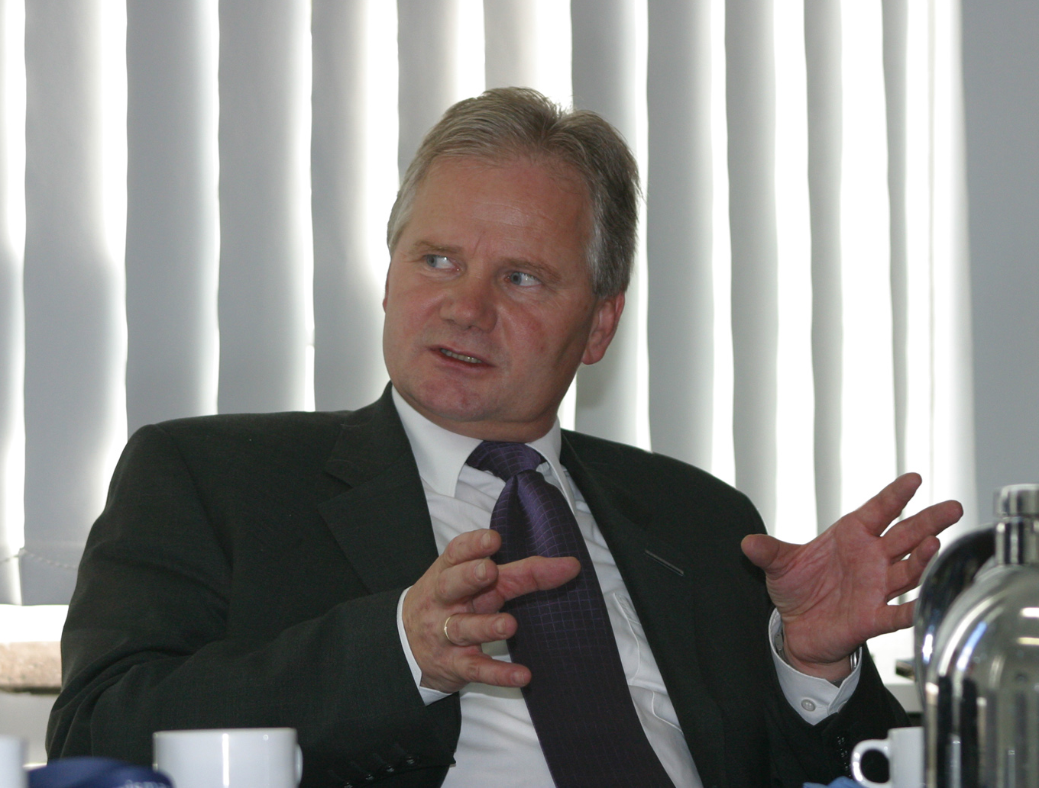 Prof. Dr.Norbert Grünwald
Rector

Hochschule Wismar

University of Applied Sciences

Technology, Business and Design

PF 1210
23952 Wismar

Tel: ++49 3841 753 2290
e-mail: norbert.gruenwald@hs-wismar.de

Curriculum Vitae

Personal dates:

Name: Prof. Dr.Norbert Grünwald
Date of Birth: 05. October 1953
Married since 1989, one daughters

Education, Profession:

Sept.60 – July 68 Polytechnical School in Rostock
Sept.68 – July 72 Gymnasium in Rostock (Abitur)
Okt. 72 – Mai 74 Military service
Sept.74 – July 79 Study, University of Rostock, Mathematics
Since Sept. 75 individual study program: Discrete Mathematics
Sept.-Dec.77 study abroad: Debrecen, Hungary
July 1979, “Diplom” in Mathematics (equivalent to a Master degree)
Sept.79 – Aug.84 Scientific assistant at University of Rostock, Department of Mathematics (PhD study)
June 1984 doctorate PhD, Discrete Mathematics
Sept.84 – Aug.86 Scientific staff at Deutsche Seereederei Rostock (German sea shipping line)
Sept.86 – Sept.91 Scientific assistant at Hochschule für Seefahrt Warnemünde/Wustrow (Maritime University), Institute for Mathematics
Oct. 91 – Sept.92 Sientific assistant at University of Rostock, Department of Mathematics
Since Oct.92 Professor for Mathematics and Operations Research at Hochschule Wismar (Wismar University), Department of Mechanical Engineering / Process and Environmental Engineering
Oct.94 – Sept.98 Vice-Dean, Mechanical Engineering / Process and Environmental Engineering
Oct.98 – Aug.02 Dean, Mechanical Engineering / Process and Environmental Engineering
Sept.02 – Jan.14 Rector, Hochschule Wismar - University of Applied Sciences: Technology, Business and Design
Since June11

Membership/Present Positions

Hochschule Wismar - University of Applied Sciences: Technology, Business and Design

Rector (2002-2014)
- Deutsche Mathematiker-Vereinigung (German Mathematical Society, DMV)
(since 1991)
- Gottlob-Frege Centre - UICEE Satellite Centre for Engineering Science and Design, Hochschule Wismar-University of Technology, Business and Design (since 2000)
- Mathematikolympiaden e.V (Society of German Mathematical Olympiad)
Member (since 1989)
Member of the Jury, Chairman/Vice-Chairman of the Mathematical Task Commission (since 1995)
- ECEBE – European Centre for Engineering and Business Education,
Hochschule Wismar – University of Technology, Business and Design, Germany
Director (since 2007)
- Technologie- und Gewerbezentrum (Technology and Commercial Centre)e.V. Schwerin/Wismar, Germany
Vice-Director of the Executive Committee (since 2004)
- Technisches Landesmuseum Mecklenburg-Vorpommern, Germany
Member of the Executive Committee (since 2003)
- Nordmetall Stiftung (foundation of the metalworking industry in northern Germany
Member of the Board of Trustees (since 2003)
- Kuratorium Gesundheitswirtschaft (health business) Mecklenburg-Vorpommern
Member of the Board of Trustees (since 2007)
- Mathematikolympiaden e.V (Society of German Mathematical Olympiad)
Member
- Scientific Advisory Council of the University of Applied Sciences, Saarland
Member (since 2008)
- Gründerflair e.V. (Network of Entrepreneurship Activities in Mecklenburg-Western Pommerania)
Chairman of the Board (since 2009)
- UNESCO International Centre for Engineering Education (UICEE), Monash University, Melbourne, Australia (1997-2008)
- UNESCO Centre for Engineering Education (UICEE), Monash University, Australia
Member of the Academic Advisory Committee (2003-2008)
- International Liaison Group for Engineering Education, (ILGEE), Australia
Deputy Chairman (1997-2008)
- UICEE – European Headquarters, Hochschule Wismar – University of Technology, Business and Design, Germany
Chairman (2004-2006)
- Member of the Research Council at University of Ohrid, (since 2011)
- Technologie- und Innovationskreis Wirtschaft/Wissenschaft Mecklenburg-Vorpommern
Member (2010-2014)
- Robert-Schmidt-Institute, Hochschule Wismar
Director (since 2011)
- Guestprofessor at Shenyang Jianzhu University, China (since 2012)

Accreditation
- Accreditation Agency for Study Programs in Engineering, Informatics, Natural Sciences and Mathematics (ASIIN), Germany
- Member of Accreditation Commission (1999-2008)
- Representative in Technical Commission 1
(Mechanical engineering/Process engineering) (1999-2008)
- Member of about 15 Audit teams for engineering programmes in Germany
(since 2000)
- Member of the EUR-ACE observer team in Dublin, Ireland, and Samara, Russia, and Tomsk, Russia, (2008)
  - Chairman of the certification committee (Zertifizierungsausschusses) of ASIIN (since 2011)
  - Member of the EUR-ACE observers team in Galway, Ireland (Engineers Ireland)
(2014)

- Nomination as Chairman of the Faculty Audit Panel to audit the Faculty of Science and Engineering of the Auckland University of Technology between the 2nd and 4th November 2004

Projects:
- TEMPUS Project-leader, ECDEEAST: Engineering Curricula Design aligned with EQF and EUR-ACE Standards, for 3 Russian universities (TPU (Tomsk), BMSTU (Moskau), SPbSPU (StPetersburg))

Publications and Editorial (in Engineering Education)
- Over 150 papers in international and national professional journals
- Plenary addresses at over 20 international conferences
- Associate Editor, Global Journal of Engineering Education, Melbourne, UICEE, Australia (1999-2008)
- Guest Editor, Global Journal of Engineering Education, annual special edition in German language, Melbourne, UICEE, Australia (2000-2007)
- Associate Editor, World Transactions on Engineering and Technology Education, Melbourne, UICEE, Australia (2002-2008)
- Publication Committee, International Journal of Technology and Engineering Education, National Changhua University of Education, Taiwan (since 2004)

Knowledge of foreign Languages
- English, negotiable communication (speaking and writing)
- Russian, basic communication (speaking)

