2026-03-23 CDIO Leaders Meeting Notes
Secretary Karin Capó Milding from the CDIO Office
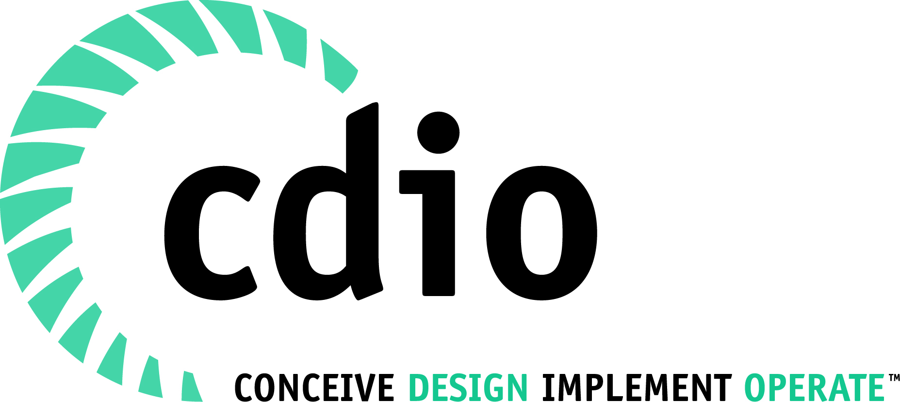

Agenda
- Conference 2026 update
- Action plan reflection
- Status of CDIO members
- Future of CDIO – update on the progress
- Regional reports
- Other topics

Conference 2026 Liverpool update
Theme
Enhancing Student Professional Development: Innovation in Assessment and Feedback
The conference will explore innovative assessment approaches that support the development of professional engineering competencies, skills, and attitudes.

Conference Overview
Update provided by Tony Topping
Dates: 22–25 June 2026

Submissions & Participation
Total presentations: 81
  - EER papers: 23
  - Advances in CDIO: 10
  - CDIO Implementation: 42
  - Projects in Progress: 6
Additional activities include:
  - 17 workshops (including keynote workshops)
  - 4 introductory CDIO workshops
  - 12 roundtable discussions

Keynote Speakers
Pleun Hermsen (TU Delft) – focus on reflection in education
Rhys Morgan – Director of Education and Skills, Royal Academy of Engineering
Venue
The conference will be held at Teaching Hub 502, offering lecture theatres, collaborative learning spaces, breakout rooms, and social areas, with the courtyard used for networking and breaks.

Discussion Points
Global situation and travel considerations
  - Question raised regarding the impact of global instability on attendance.
  - No significant impact identified so far.
  - The situation will continue to be monitored.
  - Possibility of an online participation option may be considered.
  - Noted that some countries (e.g. Australia) currently advise a high level of caution for travel to the UK.
Program flexibility
  - The conference schedule is not yet finalized and can be adjusted.
  - Participants are encouraged to provide input.

Important Dates
Registration deadline: 30 April 2026

Further Information
Conference website: https://www.cdio2026.co.uk/
Additional details available in the attached presentation (PPT)

Action plan reflections
We discussed about the current state of activities listed in the CDIO action plan. The table below summarizes the actions and status of each action.

CDIO as Framework, Community – related activities
ID | Activity | Description | Status 11.3.2026 | Next steps
C1 | Future of CDIO | CDIO standards and additional standards are key resources of CDIO framework. This activity will work on the overall standards composition and focus. | New proposed framework was further improved and commented at Hertfordshire meeting | Work continues at leaders meeting 23.3.2026 and in Liverpool (roundtable+council)
C2 | Introductory workshops and sessions for newcomers | This activity will create a proposal of standard structure and content for the future. | First version of new Intro run at Melbourne. Feedback collected. Workgroup working on next evolution of the workshop package | Workgroup to finalize new update and run it at Liverpool
C3 | Conference and events  development |  | Handbook to be updated in 2025 (Helene coordinates) Ready by February 2026 (Mark & Jens adding online chapter) | Final version to be updated.
C4 | Updating CDIO collaborators list |  | Regions working on updating the information | Each region to check their situation
C5 | Faculty  development | The main idea is to focus on whether we can build a competency map for lecturers and Technicians who teach in CDIO courses as well as suggest possible support structures to acquire these competencies. The standards will also therefore we updated accordingly. So in Liverpool, we intend to chart the main way forward and finalise the action plan. | Learnings from 2025 IWM will be processed and a plan on how to move forward will be formulated. | Work continues at Liverpool: We intend to chart the main way forward and finalise the action plan.
C6 | Assessment | Ensure all standards are equally addressed and operated (Focus on Faculty development and Assessment) |  | Submissions and activities in Liverpool
C7 | CDIO Syllabus update in relation to AI |  | 2025 IWM: rephrase syllabus -- what’s there to show that CDIO has considered AI | Work in continues at Liverpool; Papers & discussions
C8 | CDIO history  documentation | Documenting the CDIO history in a structured way. | History session at IWM 2025 and at Hertfordshire meeting 2026 Jan | Session at Liverpool?

On-going activities in CDIO
ID | Activity | Description | Status 23.10.2025 | Next steps
O1 | Peer-to-peer  support | A continual development learning process between two (or more) CDIO members at program/department level | Workshop in Melbourne and a paper presentation (Batangas – SP). | Workshop in Liverpool
O2 | Curriculum Agility | Curriculum Agility is to be responsive to changes in societal, industrial, and students’ characteristics and needs,  by proactively adapting relevant organisational structures and relevant curriculum elements in a timely manner. | Paper presentation in Melbourne on enablers of Curriculum Agility | Working group in Liverpool
O3 | CDIO Technician Network | The overarching aim is to improve faculty- technician partnerships in the design and delivery of learning activities. | Working group at Melbourne. P2P support identified this as one topic to work further. | ?
04 | Continuous  education for Engineers |  | IWM2025: Enablers and barriers for collaboration among CDIO were discussed as well as the role of CDIO organization in LLL. | Work continues at Liverpool

Status of CDIO members

The current CDIO membership consists of 233 institutions. Approximately two-thirds of members are based in Europe and Asia. The membership catalogue has been fully updated and reflects the current status.
See the chart below showing the situation on different regions.

Figure 1. CDIO member school status in different regions.

The Future of CDIO – update on the progress..
The CDIO initiative is currently working on modernizing its standards by integrating additional elements that are currently lacking. The idea is to organize the CDIO standards into clearer thematic clusters and make the framework both more comprehensive and easier to understand.
The discussions have been going on in number of previous CDIO events and meetings:
- Turku 2022: CDIO Value proposition for senior collaborators
- Trondheim 2023: Value of being in CDIO
- Bulacan 2023: Value of being in CDIO
- Tunis 2024: Identifying strengths and weaknesses of current framework
- Singapore 2024: Current state and challenges
- Porto 2025: How can we make the CDIO Initiative ”future-proof”
- Melbourne 2025: Create an alternative presentation of the standards
- Linköping 2025: Organize standards in thematic clusters and discuss needed standards
- Hertfordshire 2026: First new draft in discussion.
Based on discussions, Juha presented the latest evolution draft of the new CDIO standards framework. The framework covers the CDIO standards 3.0 version and adds new elements on organizational leadership, connection with society, future oriented elements and students engagement.
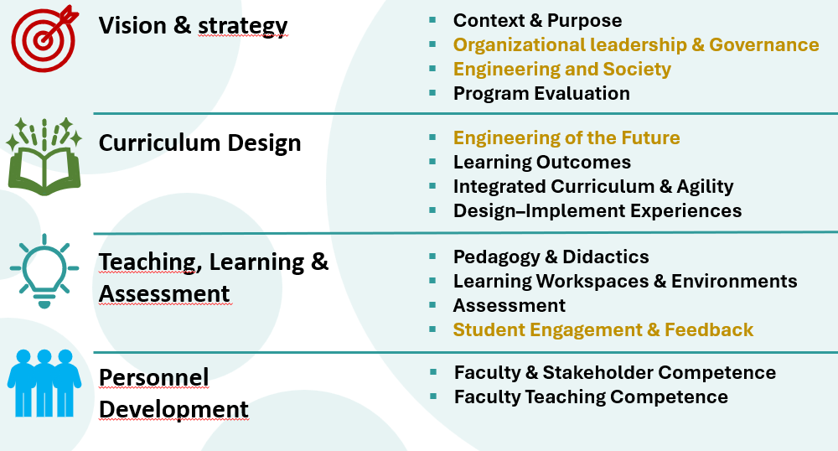
The overall feedback indicates that the work is moving in the right direction. However, further refinement is needed on the terminology used and their definitions. Furthermore, the elements alignment on concept width and depth were discussed. Naming of Curriculum design cluster was also raised.
The work continues in Liverpool and members are encouraged to participate in the round table discussion there. This theme will also be one of main topics at the International Working Meeting in Barcelona.

Regional Reports
Africa
- No representatives present & no updates reported.

Europe
- European leaders met last week to review regional activities.
- Calle will take on the role of new regional leader.
- The list of active members has been reviewed and updated.
- Regional clusters are continuing to grow in size.
- Discussions have started regarding future formats:
  - Potential for alternating online conferences (every other year)
  - Increasing frequency of in-person regional meetings
- Ongoing focus on recruitment and regional growth.

UK & Ireland
- No major updates.
- Manchester Metropolitan University has joined as a new member.

Australia & New Zealand
- Engagement with a new university interested in joining CDIO.
- The institution is expected to submit a written application and present at the Liverpool conference.
- Joanne is stepping down from her role within CDIO (not from the Council).
- Acknowledgement was made of Joanne’s valuable contributions to CDIO and the committee.

Asia
- Report delivered by Anh Quang via Sin Moh Cheah.
- Growing interest in CDIO across the region.
- Previously inactive members in India have re-engaged.
- New interest from institutions in:
  - India
  - Vietnam
  - The Philippines
  - Uzbekistan
  - Malaysia
- Ongoing collection of “caselets” to document CDIO implementation.
- Current activities include:
  - Workshops in Cambodia
  - Advisory support for regional meetings and conferences in Kazakhstan
  - Handling membership inquiries
- A new institution in Kazakhstan is preparing an application for CDIO Asia membership.
- Work is ongoing to identify a host for the Asia Regional Meeting 2027, with preliminary interest from Thailand.

North America
- No representatives present & no updates reported.

Latin America
- No representatives present & no updates reported.

Other Topics
CDIO Leaders Meeting – Notes & Reminders
- Upcoming Dates
  - 20 May – Next CDIO Leaders Meeting
  - 22–25 June – CDIO International Conference

Reminders
- Call for Conference Hosts (2028)
  - Members are encouraged to consider hosting the 2028 CDIO Conference.
- Elections – Leadership Positions
  - There are one co-director and three members-at-large positions to be filled.
  - The member-at-large positions and terms are
    - Position A: 2026–2029 (currently held by Matt)
    - Position B: 2026–2029 (currently held by Vairavel)
    - Position C: 2026–2027 (currently held by Joanne)
  - The election committee will invite expressions of interest from the community.

Other Updates
- 2025 Conference Proceedings
  - The proceedings from the 2025 International CDIO Conference have now been successfully indexed in Scopus.
  - Special thanks to Fredrik Byström for his excellent work in achieving this.

Participants
Name
Kontio Juha
Fariz Mammadov-AzTU
Karin Capó Milding
Joseph Orisaleye
Cesar Ortega-Sanchez
Mark Nivan SINGH (SP)
Tommy Lundström
Svante Gunnarsson
Vairavel Gurusamy
Carl-Johan Carlsson
Nicoleta Maynard
Anh-Quang Dao
Joanne Tanner
Topping, Anthony
Jerker Björkqvist
Angelo Martins
Kirsten From
Reidar Lyng
Nis Ovesen
Suzanne Brink
Gommer, Lisa (UT-ET)
Mats Syde
IGNAT Sorin
Niklas Eriksen
Rajakarunakaran
Mette Mo Jakobsen
Marius Birkeland
Politeknik Negeri Malang
Ratih_Polinema Indonesia

